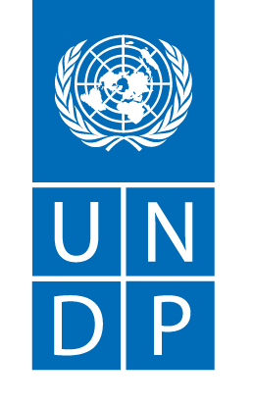
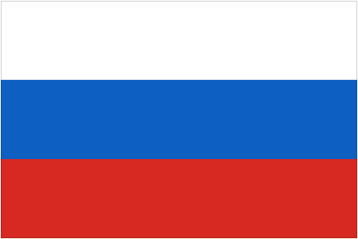

With financial support from
the Russian Federation

The Russian Federation-UNDP Trust Fund for Development

FULL NAME OF THE PROJECT
Name of the country (if regional, put ‘regional’ and list all participating countries)
Final report

The template of Project Final Report approved by the virtual meeting of the TFD Steering Committee, February 2021

The Russian Federation-UNDP Trust Fund for Development (TFD)

Project Final Report

Project title:

Atlas Project ID:

Implementing partner(s):
Project budget: | Total:  TFD:  Other sources:
Cofinancing attracted for the project implementation: | Please specify the source (national government, international partner, etc) and the type of cofinancing already received  Direct contribution to project budget:  Parallel cofinancing:  In-kind cofinancing:
Project start and end date: | If project was extended, please specify both the initial date and final ones

SDGs supported by the project:

Please refer to the UNDP Editorial Style Manual for guidance on numbers, acronyms and other aspects.

When mentioning the events, please make sure you specify the name of the event, exact dates and venue (city and country or online).

Use of pictures, infographics, short beneficiary storis is highly encouraged.

You may wish to consider creating several versions of the final report: for the TFD based on the current template, for wider public with less detail but more graphics, for national partners, etc. Please share all types of final reports with TFD Secretariat for information.

Please delete all notes in italics including this one prior to submitting the report.

TABLE OF CONTENTS

ACRONYMS (in alphabetical order)

1. EXECUTIVE SUMMARY (1-2 pages, here and below the suggested length is given)

Please provide a short summary of the main development results, highlighting progress against outcomes and linkages between outputs and the outcome, their impact on achieving the goals of the project.

Outline main challenges, risks and mitigation measures.

Include key recommendations for decision-making purposes if any.

2. RESULTS (10-20 pages)

Please include an overview of the situation analysis, objectives and changes in the context/situation of the project implementation.

Please describe the main results achieved by the project and how they contribute to outcomes as outlined in the project document and expected outcomes as per the Country or Regional Programme Document. Give an overall and clear sense of the “before-and-after” of the project intervention.

Use of examples, evidence, feedback by beneficiaries, personal stories of beneficiaries and reference to relevant SDGs is encouraged.

The results should be structured in accordance with project components per the project document (they can be used as headings for subsections). When describing activities put the emphasis on linking them to outputs by including references and evidence on how the total number of activities helped to reach the output and outcome level achievements.

Please provide an estimate of the number of direct and indirect beneficiaries.

Project performance data should be attached as an annex and relevant indicators should be disaggregated by gender.

Very briefly describe the types of Monitoring and Evaluation activities (field visits, assessments, reviews, surveys, evaluations etc.) undertaken during the project. If evaluation was undertaken, please briefly mention its main findings and recommendations.

3. SUSTAINABILITY OF THE ACHIEVED RESULTS AND FUTURE PLANS (2-3 pages)

Please provide information on steps taken to ensure sustainability of the results. Please share examples of sustainable arrangements and / or results that were already visible at the project’s final implementation stages.

Please specify how stakeholders, counterparts and/or local communities were engaged in the planning, implementation, monitoring and evaluation of the project to ensure sustainability of the project.

Please reflect on scaling up opportunities if any.

4. CHALLENGIES AND LESSONS LEARNT (1-2 pages)

Mention key challenges encountered during the project and lessons learned. Describe successful approaches taken to address challenges and highlight recommendations for future consideration.

5. RISKS AND MITIGATION MEASURES (0.5-1 page)

Please provide a short overview of whether the risks indicated in the project document or any other risks occurred. Specify the responses taken including any project adjustments.

6. PARTNERSHIPS (1-2 pages)

Please provide information on main impact on results achieved via partnership with various stakeholders and institutions.

For a large number of partners, a table form might be preferable.

7. PARTNERSHIP WITH THE RUSSIAN FEDERATION (1-2 pages)

Please provide information on the main results achieved via partnership with the Russian Federation, including
- Cooperation with Russian institutions;
- Use of Russian expertise;
- Alignment and coordination with other Russia-funded projects in the area of project implementation, including projects implemented by other international organizations.

Please outline how partnership with Russian institutions and other Russia-funded projects contributed to the sustainability of project’s results.

8. COMMUNICATION AND VISIBILITY (1 page)

Please provide details on the communication results. Media coverage data should be included in the annex featuring the information on the main news stories describing project results. It is encouraged to provide a link to the storage of the pool of best project photos.

9. FINANCIAL MANAGEMENT
OUTPUT | Budgeted | Delivered

Output 1

Output 2

…

TOTAL:

Submitted by_______

Cleared by _________(CO Quality Assurance)

Cleared by _________(CO Official)

Date_______________

10. ANNEXES

10.1 Project performance data

Indicator data disaggregated by gender when applicable can be organized in a table form following the results framework format:
Outputs | Output indicators | Data source | Baseline |  | Target for the project per ProDoc |  | Actual value achieved for the project
 |  |  | Value | Year
Output 1 | 1.1
 | 1.2
… | …
Activities |  |  |  |  | Results
EXAMPLE  Activity 1: Reintegration process for 4,450 participants in the Central Sector completed. |  |  |  |  | 4,310 out of the 4,450 DDR participants targeted for the Central Sector have been provided with reintegration support.
1.1. Delivery referral, registration, training and reintegration packages (agriculture tools, livestock, small business items, etc.,) to participants.  1.2. Provide required follow-up services to support the reintegration process of DDR participants |  |  |  |  | 1.1. Delivery, referral, registration, training and provision of reintegration support were wrapped up during the third quarter of 2019. As of 30 September 2019, 4,460 ex-combatants were registered with RPs. Reintegration of 4,310 ex-combatants is completed.  1.2. RPs has also continued to provide follow-up and advisory services to beneficiaries that have received their reintegration support.
Output 2 | 2.1
 | 2.2
… | …
Activities |  |  |  |  | Results

10.2 Media coverage report with links to main publications

10.3 Statistical annex on main results since the project start (will be attached separately in Excel).
Annex includes data on estimate number of direct beneficiaries, estimate number of indirect beneficiaries, cofinancing by national and local partners, cofinancing by UNDP and international partners, number of national, province and local partners engaged in implementation, number of Russian organizations engaged in implementation, number of Russian experts engaged individually, estimate number of news and other media pieces where project was featured

10.4 Evaluation reports if available

10.5 - … Any other annexes can be added if deemed necessary by the project team. Examples may include personal stories of project beneficiaries, outline of main projects supported under the area-based programmes, etc.

